Life Habitat: Task Management App

## Team Ethernet

Team members: Brianna Gannett *(Project Manager)*, Roisin Rumsey *(Designer)*, Sarah Turmel *(Developer)*, Emily Scott *(Developer)*, Dean Hauser *(Developer)*

# Problem

Many individuals struggle to stay motivated to complete essential yet tedious tasks, such as grocery shopping, doing laundry, and preparing healthy meals. When people aren't motivated, they might put off important, tedious tasks, causing them to build up and become overwhelming. This procrastination can lead to late tasks, which adds to the demotivation and puts individuals in a negative headspace.

Task management software has been used as a prior solution to this problem. Examples include Notion, Slack, Monday, Click Up, Stikk, Finch, BetterMe, and more. Although this software can be efficient and keep you organized through calendars, due dates, and more, it does not make doing the work enjoyable. Not only that, but lots of these task management software focus a lot on team tasks and working together, rather than on individual tasks. Suppose there was software that had excellent task management for individuals and also made users excited to use it through rewards and Tamagotchi-like gameplay. Would users be more motivated to do their essential, tedious tasks?

# Prior Solutions

## Solution 1: Stikk

Stikk is a web application that allows users to pick specific goals to stick to and achieve. When a user creates their goal on Stikk, they choose how much they intend to commit to their goal and choose whether to place a financial stake. If they fail to meet their goals, they can designate a charity to receive the money, providing an extra incentive to stay on track. Users also select an accountability partner which is someone who can report on their progress to the app. Based on the reports, Stikk would either punish or reward the user for their performance. Punishments may involve donations to the chosen charity if enabled, while rewards can include badges, encouraging messages, and recognition within the user’s community when they share their Stikk page with others.

Our application, on the other hand, will not lean into the punishment aspect as much. It will focus on positive reinforcement through rewarding messages and badges to keep the user encouraged to commit to their goals. Our application will feel more like a game to keep the user engaged and having fun. If the user is having fun interacting with the application, they will be more likely to continue completing their tasks and sticking to their goals. This will in turn help them continue to build better habits and develop positive behaviors that will benefit them in their everyday lives.



## Solution 2: Finch

Finch is a mobile app for iOS and Android that was designed to encourage self-care in those who were struggling with various mental health issues. Finch gives users a bird widget, much like a Tamagotchi, that reacts based on how well they meet various goals and have healthy habits. The app tracks goals, and habits, and encourages self-reflections in activities like journaling and yoga. Finch also allows users to add friends to ‘your mental health journey’, in a way that lets you connect and share progress. There is a free version of the app, however, most features require a $5 monthly subscription. Users have praised the app for features like Creating Daily Goals and Practice Breathing Exercises, while others have shared disappointment in the app's lack of response when failing to meet a daily goal 8 days in a row. Users have also mentioned that while there is a small amount of customization for your bird Tamagotchi, individuals who don’t care for birds can have trouble feeling encouraged to take care of this Tamagotchi.

Our application will be different because it will allow users more control over their experience. With options for focus areas, like motivating to do school work or just basic self care users will be able to ensure the app is helping them with exactly what they need assistance with. And more Tamagotchi customization options can help motivate users to care for their creature and themselves. Our app is mainly focused on motivation and helping people meet their daily goals, so there would be options and insight given to the user when they do not meet a goal. By having a more gamified approach, our app differs from Finch’s widget-based style, it allows users to have more fun and active interactions with their goals.

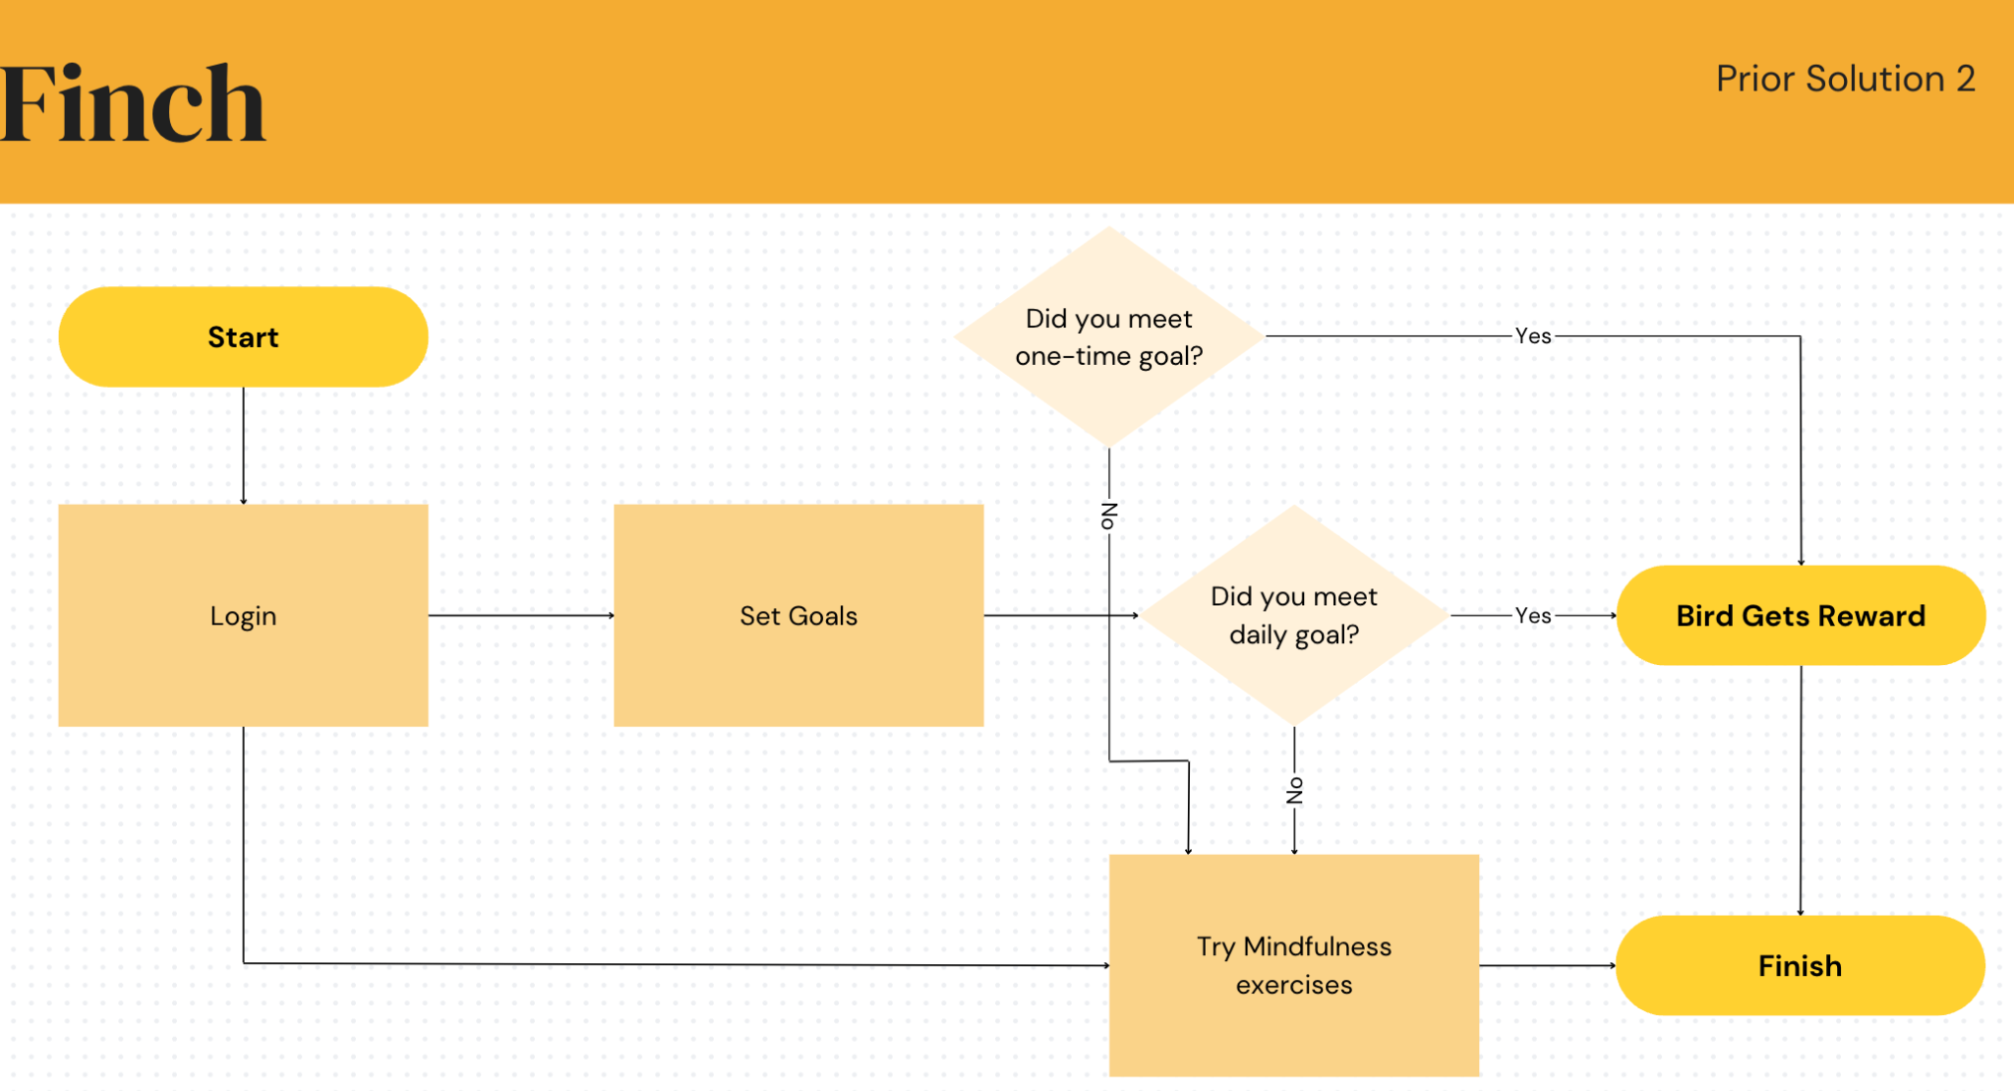

[edit](https://www.canva.com/design/DAGSV8SvB7o/SZeaTwZwPBuup59gUjoUWw/edit?utm_content=DAGSV8SvB7o&utm_campaign=designshare&utm_medium=link2&utm_source=sharebutton)

## Solution 3: BetterMe

BetterMe is both a mobile app and web application available through the Google play store and apple store, and on the web. BetterMe aims to help users primarily through customizable fitness goals, but also provides nutrition and diet plans. The app provides different fitness trajectories including pilates, calisthenics, and somatic workouts. Additionally, the app sports meal plans with dishes picked according to user preferences, intermittent fasting guides, and both a calorie and water tracker. However, this app is not free, and even after paying for a subscription there are further charges for various services which are constantly advertised to users, including those past the trial period and with a subscription. Users also report that the app does not always recognize progress, that the meal plans are not customizable enough to provide inclusivity, the app sets as a goal a body that may not be healthy for all users, and once you reach a certain point in your fitness journey, the workouts provided by the app are no longer right for you.

Our application will also provide users with guided help for self improvement, and allow users to set up goals and keep track of progress in a manner similar to BetterMe. However, our app will be entirely free, with no advertisements to distract or frustrate users. Unlike BetterMe, our app will focus on wholesome and encouraging messages that are aimed to help users meet basic needs and goals such as completing daily tasks, setting timers, and tracking sleep. This will ease the pressure put on the user to follow intense self help plans that intend for all users to reach the same goal.



# Our App: Life Habitat

Life Habitat is an app that motivates individuals to complete tedious and boring tasks through a reward-based system. Our users can set goals and tasks they need to do with due dates. If the goal is completed within the time frame, users will be able to receive a prize that can be used on the app. Not only that, but users will be able to use AI to help suggest tasks based on previous tasks.



Life Habitat is a life management, task helper application designed for users that struggle with making healthy choices and completing daily tasks. It will be designed to gamify making healthy choices and completing tasks. Users will have a small avatar that is a small pet or buddy that they care for by taking care of themselves. This will help work around some people’s lack of pathos for their own wellbeing, by invoking the need to care for an avatar. Users will set up a list of daily and weekly tasks they wish to accomplish and as they work through the tasks they will get points to spend on caring for the helper in the app, as well as cosmetics to personalize the app.

Life Habitat will have a daily task calendar where users can add, change, or remove tasks. Users will be able to set repeat tasks such as weekly shopping trips, doctor's appointments, and meetings, or daily tasks like brushing their teeth. When a user completes their task they can mark it as completed to receive a small reward. At the end of each day the app will give them feedback on how they did as well as some small bonuses if the user did well, or some helpful tips or motivation to do better if a day went poorly. Life Habitat will also have links to other self help resources and motivational stories to help encourage healthy living and user motivation.

The team at Life Habitat believes that making the daily tasks a more enjoyable part of your day will improve motivation to do them. That Is why we are designing the app to be fun to use, with customization options, games, and activities built to positively encourage the user. Taking care of their daily tasks to help their avatar buddy and allowing them points to spend on games and activities will be the core way we will try to motivate our users to make better, healthier decisions.

Tentative website layout description

Welcome page – Avatar visible with friendly welcome message, most recent task reminder, points/stats, and links to other pages

Avatar page – Shows the stats of the avatar, what things it needs, customization options, links to games

Games page – Page with games to play with the avatar, eg. A cooking mini-game, relaxation activities, other ways to spend, or earn points for the avatar

Task Page – Page that allows users to start tracking tasks and activities for their day/week. Allows for adding, modifying, deleting, repeating.

Shop page – Page to spend earned points on customization or other items for the avatar or games pages

Options page – Page to set options for notifications, how often the app should reach out, sound, and other options

Login page

Registration page